GRA-UML Defaults
To make the modeling process simpler and also to provide for flexibility in the technology and documentation artifacts produced, GRA-UML utilizes defaults at multiple levels. This document is intended to clarify the default mechanisms.
GRA_UML utilizes a 2-phase provisioning process. Some of these defaults are processed in phase-1 where as others are processed in phase-2. Note that using the “template” mechanism of phase-2, the phase-2 defaults many be modified by the NIEM-UML architect by providing an alternative template whereas the phase-1 defaults are specified by the GRA-UML standard and are not modifiable.
Defaults fall into the following categories:
- Service hierarchy defaults, expanded in phase-1
- Interaction Requirements defaults expanded in phase-2
- Property value defaults provided in phase-2

Service hierarchy defaults
This section augments section 7.4.4 in the current specification.
A service specification and the typical WSDL artifacts produced from it follow a hierarchical pattern of:
- Service interface specification
  - Service
    - Port
      - Interface
        - Operations or signals
          - Parameter
            - Message
The output from phase-1will have an annotation instance for every service, port, interface, operation, parameter and message as defined by the logical service specification. These will correspond to the
- Service component realized by the service interface specification
- Ports on those service components
- Interfaces provided or used by those ports
- Operations (or signals) contained within those interfaces
- Parameters on the operations
- Messages that are the data types of the parameters
It would be complex to fully reproduce this hierarchy just to set one or two special properties on something deep within the hierarchy – so defaults may be used. Phase-1 will generate default values for parameters. Where these default values are not as-needed the modeler creates a default. A default is an annotation instance that is linked to an element further up the hierarchy. That default will then apply to anything within that part of the hierarchy.
If a default instance realizes a PIM element the default applies only to that element. If the default instance does not realize anything, the default applies to all instances of that type unless a more specific default is supplied.
A default “lower down” in the hierarchy will always override a default further up in the hierarchy.
The processing of service hierarchy defaults is processed in phase-1, therefor the annotations intermediate file will never contain these defaults.

Example
The SIRS example has a default for “RelocationPackageInterface” as follows:
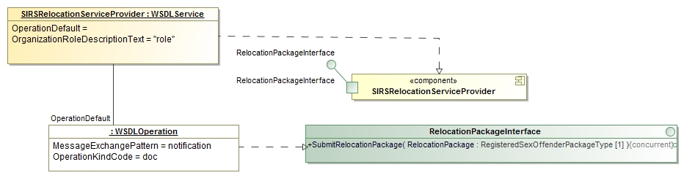
This says that RelocationPackageInterface will have a MessageExchangePattern of “notification” and and OperationKindCode of “doc” anywhere within the SIRSRelocationServiceProvider.

Interaction Requirements defaults
Interaction requirements specify the business requirements for a service interaction. Interaction requirements are specified using the following class:
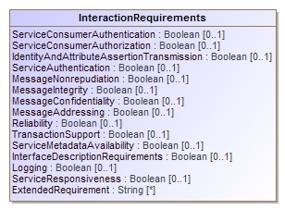
Interaction requirements are meaningfull throught the full hierarchy of an SSP, starting with the “Service Description” and proceeding along the service hierarch defined above.
The InteractionRequirements specified at the level of the SSP are considered business requriements and are included in the GRA SDD document. These requiremetns also service as a default for all the lower levels of the hierarchy, but any level of the hierarch may override the more general requirements and specify the interaction requirements at any level.
If the interaction requirements are the same for the entire SSP there is only the need for the one InteractionRequirement element. However it is common for specific ports, interfaces or oeprations to have more specific needs. To define these more specific needs the “Requirement” is linked to the more specific element and the requirement properties filled in.
Where an InteractionRequirement is not specified for an SSP, a generic default will be used. Any property not specificly set to true or false in any InteractionRequirement elementwill be filled in from the default of the upper layers (or a generic value in the ServiceDescription).
Phase-1 will only output the InteractionRequirements specificly provided by the model, the processing of these defaults is handled by phase-2.

Property value defaults
There re many elements that are required by the WSDL or GRA specification that are typically filled in with “boilerplate”. To simplify the model and also to provide flexibility as to the contents of this boilerplate, certain required properties may be omitted from the service specification. Phase-1 will fill in values that can be determined from the PIM. Phase-2 will then fill in any missing values with “boilerplate”. Any value that is specifically provided in the GRA model will take precedence over the boilerplate default. The GRA phase-2 template contains a specific section for these defaults for easy modification [TBD].
The accompanying spreadsheet details the property values that will be filled in within each phase. Default values are provided where the annotation model does not require a property but the GRA specification does.
Note: The spreadsheet needs to be validated against GRA requirements.

Example
The GRA specification requires a “Security” section. Many SSPs use a standard text of the form:
The service implementation must follow the Service Interface Description Document (SIDD) to meet the Security Requirements.
The service must adhere to the rules of the CJIS Security Policies regarding the Advanced Encryption Standard (AES) level of encryption.
If the “Security” link from a ServiceDescription is not provided, phase-2 will insert the above text. The properties subject to such a default defined in the spreadsheet.

